**NAMA : OKTAVIA DWI MULYANINGSIH**

**KELAS : 5A**

**NIM : 18090116**

PRAKTIKUM 2

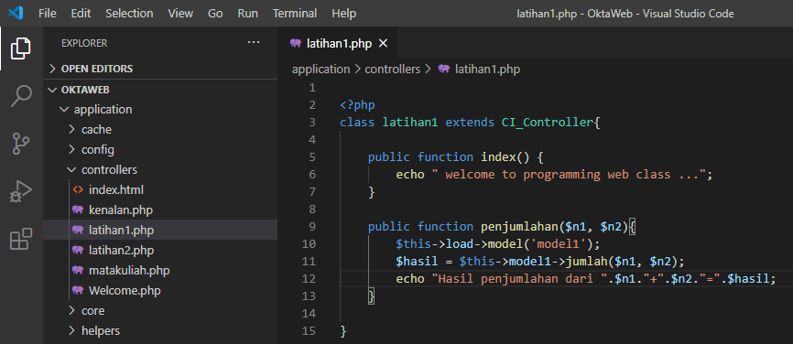Source code : latihan1.php -> application/controllers

Source code : latihan2.php -> application/controllers

Source code : viewlatihan1.php -> application/views

Source code : model1.php -> application/models

Hasil dari praktikum :

[http://localhost/pustakaokta/index.php/latihan1](%20http://localhost/pustakaokta/index.php/latihan1)

<http://localhost/pustakaokta/index.php/latihan1/penjumlahan/1/1>

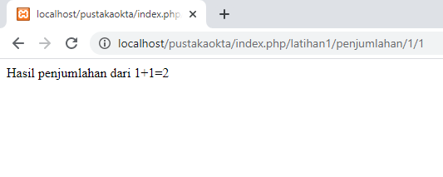

<http://localhost/pustakaokta/index.php/latihan2/penjumlahan/1/1>

